www.birdingecotours.com

info@birdingecotours.com

JAMAICA CUSTOM TOUR – TRIP REPORT
MARCH 2015

Jamaica boasts 28 endemic bird species (not including two that are possibly extinct), 19 endemic subspecies, and 18 species and subspecies endemic to the Caribbean region. This was a customized trip to try and see as many of these island specialties as possible, with a focus on getting all the Jamaican endemics. The birding tour was concentrated in the eastern end of the island with the focus of the birding being at three main locations: the arid but deceptively diverse Hellshire Hills, the cool hills of the Blue Mountains, and the lush tropical rainforests along the Ecclesdown Road in the north-eastern section of the island near the town of Port Antonio.

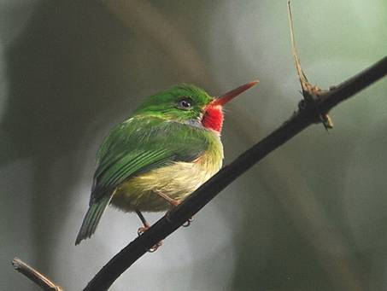
Jamaican Tody (photo Alan van Norman)

Day 1, 3rd March. Kingston and Hermitage Dam
Our clients’ flight arrived on time at 1:00 p.m. in Kingston, but we never exited the airport before 2:00 p.m. Within five minutes of driving we made our first stop along the side of the road to take a look at seabirds perched on stacks in the Kingston Harbor. There were the usual suspects: Brown Pelican, Royal Tern, Sandwich Tern, and Laughing Gull, all relaxing in the mid-afternoon sun.
The traffic had not started to build, so it took only 45 minutes to arrive at the other side of the city, where we had the choice of going birding or checking into our lodge. We chose to bird. We stopped briefly in the parking lot of a mall to look at Antillean Palm Swifts flying in and out of their nests in some palm trees. It took another 10 minutes of driving into the hills before the busy city was replaced by upscale residential homes. A little further yet, and we got to the Hermitage Dam road that leads to one of the major water reservoirs that serve the city of Kingston. The area is well forested with only a few rural homes.
Our first endemic, White-chinned Thrush, hopped on the road before our car, so we pulled over to check out the forest birds before arriving at the dam. Loggerhead Kingbird and Sad Flycatcher quickly made their presence known. The ubiquitous Bananaquit was easy to find, but with more effort we saw Yellow-shouldered Grassquit, Orangequit, Greater Antillean Bullfinch, and Jamaican Pewee. There were several doves flying around, including White-crowned Pigeon and Zenaida Dove.
The anticipation started to build when we heard both Red-billed Streamertail and Jamaican Tody, two of the most beautiful endemic birds on the island. The tody was the first to show, and we got breathtaking views. A male streamertail kept zipping by but eventually relaxed on a perch, where we could get a good view. Not long after a Jamaican Mango arrived at a banana plant flower.
Slowly making our way along the road towards the dam we got brief views of several more birds, including Jamaican Spindalis, Jamaican Euphonia, Jamaican Woodpecker, and both Jamaican Vireo and Blue Mountain Vireo. A few migrant warblers were also busy among the leaves. These included Black-throated Blue Warbler, Prairie Warbler, and American Redstart.
The dam was underwhelming, but we were still riding the high from all the birds we had seen in the forest. The few birds at the dam included Western Cattle Egret, Turkey Vulture, Great Egret, Little Blue Heron, and a very distant Black-crowned Night-Heron. By this time the need for food was more important than lifers, and we slowly made our way back into the city for a candle-light dinner on the outdoor terrace of the famous Devon House. Our lodging for the evening was at the aptly named City View Hotel in the hills of Smokey Vale, overlooking the city of Kingston.

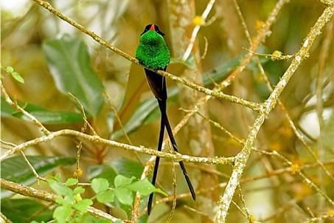
Red-billed Streamertail (photo James C. Leupold)

Day 2, 4th March. Hellshire Hills and Hope Gardens, travel to Blue Mountains
Our first birding destination was the Hellshire Hills. Since it gets hellish hot in this area, we aimed for an early start. We departed the hotel at 5:30 a.m., got breakfast en route, and arrived at Hellshire just before 7:00 a.m. Our main targets were Bahama Mockingbird and Stolid Flycatcher, as this was the only opportunity to see these birds on this trip. We drove onto the marl-covered Hellshire road, which was to be our birding route. The forest here is a very dry limestone forest with numerous cacti and short shrubs. The road goes along the coast and a few ponds with surrounding mangroves are also present.
We stepped out of the vehicle and started noticing birds moving along the shrubs. These were Palm Warbler, American Redstart, Prairie Warbler, and Black-faced Grassquit. As the sun started to head up we heard a Bahama Mockingbird singing further along the trail. We quickened our steps and found it sitting at the top of a shrub, displaying by doing a hopping flight a few feet vertically up from its perch and landing back at the same point. A few more individuals were seen, before we decided to leave. We looked and listened for a Stolid Flycatcher, but none was nearby. We eventually gave up on that one and went back into Kingston.
Lunch was at Scotchies Jerk Centre, a local jerk chicken and jerk pork restaurant. If the meat was not spicy enough we had the choice to add some of their signature hot sauce, made from scotch bonnet peppers, hence the name.
We made a brief afternoon stop at Hope Gardens in Kingston. The bird activity was low that time of the day, but we managed to find Yellow-billed Amazon resting in the trees. A single Black-billed Amazon was also seen, as well as a Yellow-throated Warbler.
We said goodbye to Kingston and started our uphill journey into the Blue Mountains. The road is narrow and twisting, but most of the potholes were recently patched. An hour went by, and we made a stop at the Newcastle Jamaica Defense Force Training Depot to take a look at Kingston from 3400ft. We went through this former British military base and then got onto the Hardwar Gap road, which stays level at this altitude for several miles.
Our first birding stop in the Blue Mountains was at Woodside Road. This is a private road leading down from the main Hardwar Gap road. We parked at the top and walked slowly down this steep road for a couple of hundred meters. There were movements in the trees above, and we realized we were being watched by a few Ring-tailed Pigeons. We arrived at a clearing, where we decided to spend about 45 minutes to see what was moving through. There were two large Jamaican Becard nests hanging in the trees, and it never took long before both male and female becards were seen. We got better views of Yellow-shouldered Grassquit, Blue Mountain Vireo, Jamaican Woodpecker, and Jamaican Spindalis. We also could not get enough of the streamertails and todies that were present too. Rufous-throated Solitaire was heard whistling all over, and after much searching we got a very short view of one that came close enough but remained within the vegetation. We heard many more throughout our time in the Blue Mountains, but that was the only one we saw.
We made our way back up the steep road to our car and continued to the lodge. This was a private two-bedroom cottage called Silver Hill Cottage on a working farm with, most importantly, a very birdy garden. A courteous helper prepared our meals during our three-night stay.
We went out into the gardens at night and managed to call in a Northern Potoo. Although it stayed a fair distance away, we were able to get a decent view.

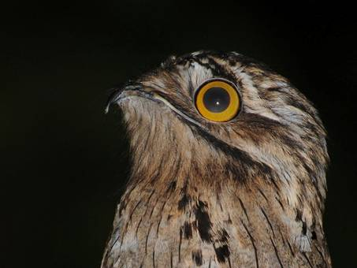
Northern Potoo (photo Alan van Norman)

Day 3, 5th March. Blue Mountains
The Blue Mountains were teaming with birds, and so we made our way to the area that would give us the best chance to see some of the rarest birds … and we were in luck. Target number one was the elusive Crested Quail-Dove. They prefer heavily shaded areas, and so we pulled over wherever the canopy closed over along the Hardwar Gap road. First it was a flyby, and then we saw one perched on a branch. Before the morning was out we had two more sightings. Arrowhead Warbler was probably the busiest of all the warblers we saw. We had fleeting glimpses the day before, but this time we got long views of several individuals.
Jamaican Blackbird is one of the rarest of the endemics and is known to be missed on week-long trips. Fortunately for us that was not the case. We got good views of several. It was almost disappointing that we found this bird so easily.
We returned to the cottage for a late breakfast and birded the gardens afterwards. There were birds everywhere. Streamertails were all over the flowering plants, and we also saw good views of a Vervain Hummingbird, the second-smallest bird in the world. A rare migrant, Yellow-bellied Sapsucker, was also a treat. We got good views of many of the endemics we saw on the first two days. White-eyed Thrush was a welcomed treat, and we had no problem finding several.
We decided to spend most of the time at the cottage as the bird life there was incredible. In the evening we ventured out a little further with cuckoos in mind. We had not seen any of those birds the entire trip so far, and we were aware that they can be tricky at times. Search as we might, there were no cuckoos for us that evening. As the sun began to set we decided to try again for Jamaican Owl. Near the lower gate of the cottage we heard it reply some distance up the side of the hill. We got comfortable and ready to play the ‘patience game’. A few more calls from the playback, and it still remained out of view. But after 20 minutes it flew down, over our heads, and into another tree that was too dense and inaccessible. Another 10 minutes went by, and then we heard it call much further away. We had to be satisfied with the brief view in flight.
We returned to the cottage for dinner and then retired for the night.

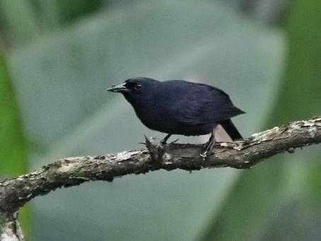
Jamaican Blackbird (photo Alan van Norman)

Day 4, 6th March. Blue Mountains
We were now halfway through our birding trip, and already we had 24 of the 28 endemics. What we were missing were two cuckoos, the crow, and the Black-billed Streamertail. The cuckoos therefore were priority number one, as the other two are not found in that area of the Blue Mountains.
This was our final day in the Blue Mountains, and so we tried to make the best of it. We traveled out from the cottage and birded along the Silver Hill Gap road towards the small village of Section. We pulled over near an abandoned bottled-water processing plant and scanned the trees and the skies. A Red-tailed Hawk soared overhead, and several flocks of Ring-tailed Pigeons flew by. Then we saw something racing along a branch and disappearing into the thick of the tree. I knew immediately what it was and made a short play of its call. Out popped a Jamaican Lizard Cuckoo with its throat vibrating as it made a loud response call. Fantastic views!
The rest of the day was mostly spent relaxing at the cottage and enjoying the gardens. We saw many more of the usual suspects and marveled at how beautiful the Jamaican Spindalis was. New birds included Black-throated Green Warbler, Ovenbird, Black-and-white Warbler, and Common Yellowthroat.

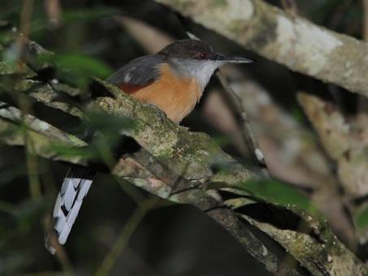
Jamaican Lizard Cuckoo (photo Alan van Norman)

Day 5, 7th March. Blue Mountains, travel to Port Antonio
After breakfast we packed and left the cottage and then birded our way down the mountain. In an area close to the community of Cascade we stopped to bird among the large Blue Mahoe trees that dominated the area. Streamertails were zipping by as they defended their feeding areas. We also got views of a few more Jamaican Blackbirds, and when they left we decided to call it quits for the morning.
Two hours of driving awaited us to our next destination, and so we continued the drive down the mountain. After an hour we were on the north coast. We headed east and took in the beauty of the island and the Caribbean Sea. We stopped at the mouths of the Spanish River and the Swift River to look for any waders or waterfowls. We added Common Gallinule, Northern Jacana, Lesser Yellowlegs, and Spotted Sandpiper to our list. A pleasant surprise at the Spanish River was a single female Red-breasted Merganser, which is a vagrant to the island.
We arrived in the town of Port Antonio and stopped at a local supermarket for some supplies, before continuing to the Goblin Hill Villas at San San, our accommodations for the next two nights. This is a very beautiful property, and the helpers prepare your meals in the kitchen in the villa. Although it is not on the beach, the beach is nearby, and we also had a pool. On arriving at the Villas we were greeted by a stunning male Black-billed Streamertail that sat on a branch no more than an arm’s reach and at eye-level. There were hummingbird feeders nearby, and a couple more streamertails were to be seen, along with a single Jamaican Mango. In this very eastern section of the island all the streamertail hummingbirds are Black-billed Streamertails.
We relaxed in the afternoon and went out walking nearby in the evening. All that was on our mind at this time was the last cuckoo. We heard another Jamaican Lizard Cuckoo, but it never showed. So we called it an evening.

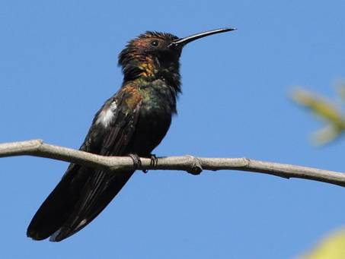
Jamaican Mango (photo Alan van Norman)

Day 6, 8th March. Ecclesdown Road
This was the final full day of birding, and we had two endemics to go and several other lifers possible. The first target was the White-tailed Tropicbird that nests along the cliffs at Hectors River, some 45 minutes drive away. We departed the villa at 5:30 a.m. and arrived at Hectors River while the sun was still low on the horizon. As we stood on the edge of a cliff near a playing field overlooking the sea we could see birds in the distance. We could make out that they were White-tailed Tropicbirds, but we waited for closer views. They seemed to fly around aimlessly, coming close to the cliffs at some point. Eventually they were just in the bay ahead of us, flying around. We could even spot some of the tiny holes on the cliff that they seem to just disappear into. A few times an individual would fly straight towards us and seemed to just disappear under our feet as it entered its nest hole. There were 11 tropicbirds in total.
We left Hectors River and made our way westerly back on the main road we had come. After 15 minutes, however, we exited at Reach Falls and drove towards the community of Ecclesdown. This road runs along the foothills of the untouched John Crow Mountains and is very rich in bird life. If there was a place we hoped to find something we missed it would be Ecclesdown Road. We got out of the car and started birding once we had left most of the houses behind. There were flocks of Black-billed Amazons, which was a welcome sight, since we only had seen a single one at Hope Gardens on the second day. Yellow-billed Amazons were also plentiful, but our main focus was to find the last two endemic birds we were missing.
It didn’t take long before we heard a couple of Jamaican Crows calling in the valley, but they were not close. As we continued birding along the road we could tell that we were getting closer to the crows. Then they appeared. First one flew by a couple hundred meters away, and then a second one came and circled over our heads before landing in a dead tree on the top of a hill. We could see it clearly, but the strong backlight and some morning mist didn’t offer a good photographic opportunity.
We never minded, as our attention was arrested by a faint croaking call. It was our last endemic, and we needed to find it. We made our way towards the area where the sound came from and waited. After zeroing in on some movements in a tree, we finally managed to get a glimpse of the long black-and-white tail of the Chestnut-bellied Cuckoo. The rest of the bird remained hidden. But after a few minutes it hopped up onto a branch in the open for all to see, and then flew across the road and down into the valley. We had done it; we had seen all 28 Jamaican endemics!
But our work was not over, as there were a few more lifers that we hoped to find, particularly the Caribbean Dove. We birded the rest of the morning at Ecclesdown and got more views of another Chestnut-bellied Cuckoo before we headed back to the hotel.
I took a short detour on our way back to the hotel to check on a reliable roosting site I had for Jamaican Owl on the property of Frenchman’s Cove. The security guard at the property knew about the bird, which has become something of a celebrity on the property since birders started going there to see it. He pointed to the tree where it was supposed to be, and, sure enough, it was sitting close to the trunk, hidden behind leaves of Dendrophyla vines that draped the large tree.

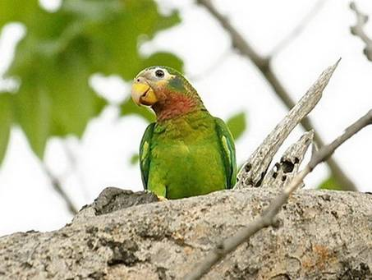
Yellow-billed Amazon (photo James C. Leupold)

Day 7, 9th March. San San and return to Kingston
Since we had seen all the endemics and the White-tailed Tropicbird, we decided not to travel back to Hectors River or the Ecclesdown Road but concentrated on birding close-by. We managed to get more views of Olive-throated Parakeet that we last saw at Hope Gardens. Another Blue Mountain Vireo was also around, and we managed to get photos.
We made a short trip over to San San and managed to find not one but two new birds. The first was Caribbean Dove, which we spotted walking with a Ruddy Quail-Dove. They both flew away, but after some time the Caribbean Dove returned and continued feeding on the ground. The second new bird was the Mangrove Cuckoo. After our failed attempt at finding this bird near the mangroves at Hellshire Hills we were finally lucky enough to see one on the last day.
Soon it was time to pack and take the 2½ -hour journey back to Kingston and the airport. In the end we had seen 97 species, including all the Jamaican endemics, 12 endemic subspecies, and one Caribbean endemic species. The only land mammal that was seen throughout the trip was the introduced small Indian mongoose.

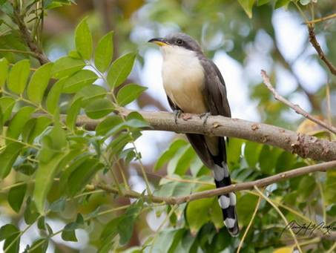
Mangrove Cuckoo (photo Quinten Questel)

SCIENTIFIC NAME | COMMON NAME | TRIP | ISLAND STATUS
Pelecanidae | Pelicans
Pelecanus occidentalis | Brown Pelican | 1 | R
Fregatidae | Frigatebirds
Fregata magnificens | Magnificent Frigatebird | 1 | R
Phaethontidae | Tropicbirds
Phaethon lepturus | White-tailed Tropicbird | 1 | R
Ardeidae | Herons, Egrets and Bitterns
Bubulcus ibis | Western Cattle Egret | 1 | R
Ardea alba | Great Egret | 1 | R
Egretta thula | Snowy Egret | 1 | R
Egretta caerulea | Little Blue Heron | 1 | R
Butorides virescens | Green Heron | 1 | R
Nycticorax nycticorax | Black-crowned Night Heron | 1 | R
Threskiornithidae | Ibises and Spoonbills
Plegadis falcinellus | Glossy Ibis | 1 | R
Anatidae | Swans, Geese and Ducks
Mergus serrator | Red-breasted Merganser | 1 | V
Anas discors | Blue-winged Teal | 1 | NBR
Cathartidae | New World Vultures
Cathartes aura | Turkey Vulture | 1 | R
Pandionidae | Ospreys
Pandion haliaetus | Western Osprey | 1 | R
Accipitridae | Hawks, Eagles and Kites
Buteo jamaicensis | Red-tailed Hawk | 1 | R
Falconidae | Falcons and Caracaras
Falco sparverius | American Kestrel | 1 | R
Falco columbarius | Merlin | 1 | NBR
Rallidae | Rails, Gallinules and Coots
Fulica americana | American Coot | 1 | R
Porphyrio martinicus | Purple Gallinule | 1 | R
Gallinula galeata | Common Gallinule | 1 | R
Recurvirostridae | Stilts and Avocets
Himantopus mexicanus | Black-necked Stilt | 1 | R
Jacanidae | Jacanas
Jacana spinosa | Northern Jacana | 1 | R
Scolopacidae | Sandpipers and Yellowlegs
Tringa flavipes | Lesser Yellowlegs | 1 | NBR
Actitis macularius | Spotted Sandpiper | 1 | NBR
Laridae | Gulls, Terns & Skimmers
Leycophaeus atricilla | Laughing Gull | 1 | R/NBR
Thalasseus sandvicensis | Sandwich Tern | 1 | R/NBR
Thalasseus maximus | Royal Tern | 1 | R/NBR
Columbidae | Pigeons and Doves
Columba livia | Rock Dove | 1 | I
Patagioenas leucocephala | White-crowned Pigeon | 1 | R
Patagioenas caribaea | Ring-tailed Pigeon | 1 | E
Zenaida asiatica | White-winged Dove | 1 | R
Zenaida aurita | Zenaida Dove | 1 | R
Geotrygon versicolor | Crested Quail-Dove | 1 | E
Geotrygon montana | Ruddy Quail-Dove | 1 | R
Columbina passerina jamaicensis | Common Ground Dove | 1 | Es
Leptotila jamaicensis jamaicensis | Caribbean Dove | 1 | Es
Psittacidae | Parrots, Macaws and Allies
Eupsittula nana nana | Olive-throated Parakeet | 1 | Es
Forpus passerinus | Green-rumped Parrotlet | 1 | I
Amazona collaria | Yellow-billed Amazon | 1 | E
Amazona agilis | Black-billed Amazon | 1 | E
Cuculidae | Cuckoos and Anis
Coccyzus vetula | Jamaican Lizard Cuckoo | 1 | E
Coccyzus pluvialis | Chestnut-bellied Cuckoo | 1 | E
Coccyzus minor | Mangrove Cuckoo | 1 | R
Crotophaga ani | Smooth-billed Ani | 1 | R
Strigidae | Typical Owls
Pseudoscops grammicus | Jamaican Owl | 1 | E
Nyctibiidae | Potoos
Nyctibius jamaicensis jamaicensis | Northern Potoo | 1 | Es
Apodidae | Swifts
Tachornis phoenicobia | Antillean Palm Swift | 1 | Ec
Cypseloides niger | American Black Swift | 1 | R
Streptoprocne zonaris | White-collared Swift | 1 | R
Trochilidae | Hummingbirds
Anthracothorax mango | Jamaican Mango | 1 | E
Mellisuga minima minima | Vervain Hummingbird | 1 | Es
Trochilus polytmus | Red-billed Streamertail | 1 | E
Trochilus scitulus | Black-billed Streamertail | 1 | E
Alcedinidae | Kingfishers
Megaceryle alcyon | Belted Kingfisher | 1 | NBR
Todidae | Todies
Todus todus | Jamaican Tody | 1 | E
Picidae | Woodpeckers
Melanerpes radiolatus | Jamaican Woodpecker | 1 | E
Sphyrapicus varius | Yellow-bellied Sapsucker | 1 | NBR
Tyrannidae | Tyrant Flycatchers
Myiopagis cotta | Jamaican Elaenia | 1 | E
Contopus pallidus | Jamaican Pewee | 1 | E
Myiarchus barbirostris | Sad Flycatcher | 1 | E
Myiarchus validus | Rufous-tailed Flycatcher | 1 | E
Tyrannus caudifasciatus jamaicensis | Loggerhead Kingbird | 1 | Es
Cotingidae | Cotingas
Pachyramphus niger | Jamaican Becard | 1 | E
Hirundinidae | Swallows
Petrochelidon fulva | Cave Swallow | 1 | R
Mimidae | Mockingbirds and Thrashers
Mimus gundlachii hillii | Bahama Mockingbird | 1 | Es
Mimus polyglottos | Northern Mockingbird | 1 | R
Vireonidae | Vireos
Vireo modestus | Jamaican Vireo | 1 | E
Vireo osburni | Blue Mountain Vireo | 1 | E
Corvidae | Crows
Corvus jamaicensis | Jamaican Crow | 1 | E
Turdidae | Thrushes
Myadestes genibarbis solitarius | Rufous-throated Solitaire | 1 | Es
Turdus jamaicensis | White-eyed Thrush | 1 | E
Turdus aurantius | White-chinned Thrush | 1 | E
Parulidae | New World Warblers
Setophaga americana | Northern Parula | 1 | NBR
Setophaga caerulescens | Black-throated Blue Warbler | 1 | NBR
Setophaga discolor | Prairie Warbler | 1 | NBR
Setophaga ruticilla | American Redstart | 1 | NBR
Mniotilta varia | Black-and-white Warbler | 1 | NBR
Geothlypis trichas | Common Yellowthroat | 1 | NBR
Setophaga palmarum | Palm Warbler | 1 | NBR
Setophaga petechia | Mangrove Warbler | 1 | R
Setophaga tigrina | Cape May Warbler | 1 | NBR
Setophaga virens | Black-throated Green Warbler | 1 | NBR
Setophaga pharetra | Arrowhead Warbler | 1 | E
Helmitheros vermivorous | Worm-eating Warbler | 1 | NBR
Seiurus aurocapilla | Ovenbird | 1 | NBR
Setophaga dominica | Yellow-throated Warbler | 1 | NBR
Coerebidae | Bananaquit
Coereba flaveola flaveola | Bananaquit | 1 | Es
Fringillidae | Finches
Euphonia jamaica | Jamaican Euphonia | 1 | E
Thraupidae | Tanagers and allies
Tiaris olivacea | Yellow-faced Grassquit | 1 | R
Tiaris bicolor | Black-faced Grassquit | 1 | R
Loxipasser anoxanthus | Yellow-shouldered Grassquit | 1 | E
Euneornis campestris | Orangequit | 1 | E
Loxigilla violacea ruficollis | Greater Antillean Bullfinch | 1 | Es
Spindalis nigricephala | Jamaican Spindalis | 1 | E
Icteridae | Icterids
Icterus leucopteryx leucopteryx | Jamaican Oriole | 1 | Es
Quiscalus niger crassirostris | Greater Antillean Grackle | 1 | Es
Nesopsar nigerrimus | Jamaican Blackbird | 1 | E
TOTAL |  | 97

Key
I = Introduced species
V = Vagrant
E = Endemic species, Es = Endemic subspecies, Ec = Caribbean endemic species
R = Resident species
BR = Breeding resident (summer migrant)
NBR = Non-breeding resident (winter migrant)

